# Course Overview

This course will focus on atmospheric and near-surface oceanographic measurements made by automated sensors. Systems on research vessels typically include a computerized data logging system that continuously records navigation (ship position, course, speed, and heading), meteorological (winds, air temperature, pressure, moisture, rainfall, and radiation), and near-surface (sea temperature and salinity) ocean parameters while a vessel is underway. Measurements are recorded at high temporal sampling rates (typically one minute or less). Although manual observations are still common on research vessels, the discussion of these sensors will be limited to their use to periodically check the operation of the automated system.

The purpose of the course is to provide marine technicians with the following:

* An overview of the science applications of these underway measurements
* An understanding of basic marine meteorology and the minimum requirements for collecting data that will support the science
* An overview of the common sensors and instruments available for routine research operations
* The knowledge to locate sensors where they will collect the highest quality data in a difficult operating environment
* The knowledge to correctly adjust sensor measurements to account for vessel motion and instrument height above the water
* An understanding of their role in assuring that the highest quality observations are collected from each underway sensor

# Source

# Much of the content for this professional development was excerpted from Bradley and Fairall (2006). <http://samos.coaps.fsu.edu/html/docs/NOAA-TM_OAR_PSD-311.pdf>

# Acknowledgment

# Development of this short course was supported by the National Science Foundation under Grant No. OCE-0947784. Any opinions, findings, conclusions, or recommendations expressed in this material are those of the authors and do not necessarily reflect the views of the National Science Foundation.Lesson 1: Why We Care (short version at INMARTECH)

Topics covered in this lesson include the following:

* Science use cases (what the data are good for)
* Minimum requirements for underway meteorological and near-surface ocean data collection
* A brief introduction to marine meteorology

## 1.1. Introduction

The importance of the routine underway collection of marine meteorological and near surface observations cannot be overstated. By their very nature, research vessels can make concurrent measurements while on another mission (e.g., survey mapping, science investigations not focused on the atmosphere, buoy and float deployment), making vessels an integral part of the global ocean-observing system. Research ships provide underway observation far outside routine shipping lanes (e.g., the South Pacific and Southern Ocean) and in economically important coastal regions, contributing high scientific value to the user community. Research vessel data are not routinely assimilated into numerical weather prediction (NWP) models; however, because of their high temporal sampling and independence from NWP, they support validations of operational models. Additionally, research vessels typically sail with technicians capable of maintaining and monitoring the underway data collection systems.

## 1.2. Requirements for science

Atmospheric and surface oceanographic observations made on research vessels contribute to scientific and operational activities for personnel on board during a cruise and for a host of secondary users post cruise. On board, the observations are used to orient the vessel for over-the-side instrument deployments and are frequently documented by science party members to provide a surface reference data value for biological or physical oceanographic work. **Accurate measurements are needed to (1) create quality estimates of the heat, moisture, momentum, and radiation fluxes at the air–sea interface; (2) improve our understanding of the biases and uncertainties in global air–sea fluxes; (3) benchmark new satellite and model products; (4) develop new satellite (and other remote sensing system) data retrieval algorithms; and (5) support numerical modeling activities (e.g., reanalysis) and global climate programs.**

The importance of accurate fluxes of heat and momentum in the coupled ocean–atmosphere system has been acknowledged since the mid-1980s. Research vessels provide the high-quality, high temporal and spatial resolution data that are ideal to measure turbulent and radiative fluxes. These data are used to develop flux parameterizations (numerical approximations of complex processes) and to evaluate gridded flux products and estimates of basic meteorological parameters, such as winds, air temperature, humidity, and cloud cover, used in numerical weather prediction model parameterization of surface fluxes.

Observations from research vessels have been used in the development of satellite retrieval algorithms and in the validation of satellite measurements. Examples include the development of algorithms for humidity and air temperature and the validation of satellite wind measurements (Fig. 1.1). High-quality data are needed under all conditions and ships provide measurements in regions unsampled by other observing-system components. The high spatial and temporal variability of underway samples allows closer matching to the satellite footprint than buoy data do. This is particularly important for wind speed and direction. Satellite retrievals of surface humidity have been validated using underway data, exposing significant differences and regional bias among satellite retrievals.

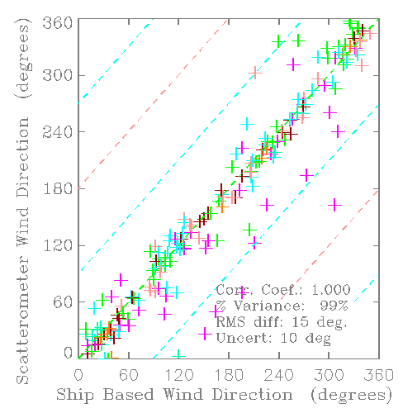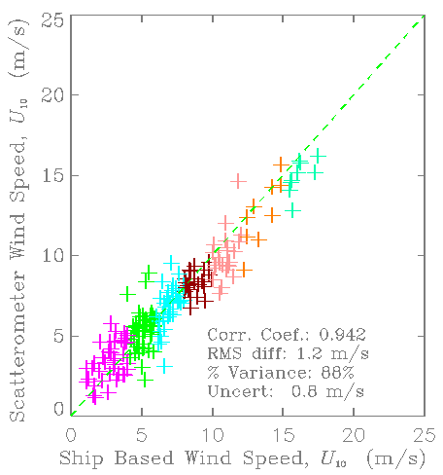Research vessel observations of sea temperature and salinity have been used to identify surface ocean density fronts. The frontal positions can be compared to those in numerical ocean models to validate the performance of the model. One recent study showed the HYbrid Coordinate Ocean Model (HYCOM) to severely underestimate fresh water input from rivers in the northern Gulf of Mexico.

**Fig. 1.1.** Difference between co-located 10-m wind (right) speed and (left) direction from research vessels and the Seawinds scatterometer on QuikScat. Crosses are color coded by the ship wind speed.

## 1.3. What to measure?

The meteorological and surface ocean measurements of primary interest to the marine climate and air-sea flux communities include the following:

* Wind speed
* Wind direction
* Air temperature
* Air humidity
* Atmospheric pressure
* Downward shortwave radiation
* Downward longwave radiation
* Rainfall
* Sea surface temperature
* Sea surface salinity

Data from the ship’s navigation system must also be recorded. In addition to providing temporal and spatial context for the meteorological and oceanographic observations, navigation data are critical in correcting for vessel motion (e.g., calculating true winds, discussed in Lesson 4). Navigation parameters should include the following:

* Latitude and longitude (typically from a global positioning system)
* True heading of the vessel (typically from a gyrocompass)
* Course and speed over the ground (from a GPS)
* Speed relative to the water (typically from a speed log or ADCP)

Additionally, each individual measurement of the parameters above must be assigned an appropriate observation time stamp representing the time the individual sensors were polled for a data value by the data acquisition system. Frequently the time is derived from a shipboard timeserver, but other sources are used.

## 1.4. Accuracy and sampling rates

To meet the broad requirements of the research community, this short course will focus on accuracies and sampling rates desired for marine climate applications, not the accuracies and rates necessary for routine daily weather observations.

Table 1 lists the required accuracy for most of the parameters outlined in section 1.3. The suite of instruments selected for a vessel should have been assembled to meet these specifications (see Lesson 2). **To meet the accuracy requirements, care must be taken during data collection to ensure the quality of basic meteorological and surface ocean variables.** Whether or not the accuracy is achieved will depend on installation and maintenance. Whenever possible, two sets of instruments should be deployed to ensure good exposure for any ship-relative wind or sun direction (see Lesson 3). At least one spare instrument of each type should be set aside as a replacement should its operational counterpart fail. Spare instruments may be stored on the vessel if the operator feels that replacements at sea are feasible.

The accuracies listed in Table 1 are based on the goal of determining the net surface heat flux to within ±10 Wm-2 on the monthly to seasonal time scales appropriate for climate studies. The reader should recognize that they are nominal values that apply to typical marine weather conditions from the tropics to the midlatitudes. These accuracies cannot be expected to apply in unusual or extreme conditions.  In the Arctic, for example, if the air temperature is -40ºC, it makes no sense to measure relative humidity to 2%. Calculated bulk turbulent heat fluxes can incur errors from uncertainties in the measurements of temperature and wind speed in extreme conditions. Consider the ±10 Wm-2 goal arbitrarily apportioned equally between radiative and turbulent fluxes. An accuracy of 5 Wm-2 in the turbulent fluxes is less likely to be met when wind speeds exceed 15 ms-1 and highly unlikely above 20 ms-1. This level of accuracy is also difficult to achieve in conditions in which the 10‑m air–sea temperature difference exceeds ±3ºC. What happens in a 50‑kt gale in the Labrador Sea in January is anybody’s guess.  However, very strong wind and/or extremely large sea–air temperature or humidity differences are sufficiently rare that long-term averages of the fluxes should fall within, or close to, the desired target.

**Table 1:** Accuracy, precision and random error targets for SAMOS.

|  |  |  |  |
| --- | --- | --- | --- |
| Parameter | Accuracy of Mean  (bias) | Data Precision | Random Error  (uncertainty) |
| Latitude and Longitude | 0.001° | 0.001° |  |
| Heading | 2° | 0.1° |  |
| Course over Ground | 2° | 0.1° |  |
| Speed over Ground | Larger of 2% or 0.2 m/s | 0.1 m/s | Greater of 10% or 0.5 m/s |
| Speed over Water | Larger of 2% or 0.2 m/s | 0.1 m/s | Greater of 10% or 0.5 m/s |
| Wind Direction | 3° | 1° |  |
| Wind Speed | Larger of 2% or 0.2 m/s | 0.1 m/s | Greater of 10% or 0.5 m/s |
| Atmospheric Pressure | 0.1 hPa (mb) | 0.01 hPa (mb) |  |
| Air Temperature | 0.2°C | 0.05°C |  |
| Dewpoint Temperature | 0.2°C | 0.1°C |  |
| Wet-Bulb Temperature | 0.2°C | 0.1°C |  |
| Relative Humidity | 2% | 0.5 % |  |
| Specific Humidity | 0.3 g/kg | 0.1 g/kg |  |
| Precipitation | ~0.4 mm/day | 0.25 mm |  |
| Radiation (SW in, LW in) | 5 W/m2 | 1 W/m2 |  |
| Ocean Surface: |  |  |  |
| Sea Temperature | 0.1°C | 0.05°C |  |
| Salinity | 0.1 psu | 0.05 psu |  |
| Current | 0.1 m/s | 0.05 m/s |  |

### Accuracy and precision

In the case of atmospheric measurements, *accuracy* is how close a measurement is to a calibrated standard. Usually instruments are calibrated on a regular schedule as recommended by the manufacturer. *Precision* is how well an instrument is able to make the same measurement repeatedly. Figures 1.2a and 1.2b are depictions of accuracy and precision. Care must be taken when reading the manufacturer’s specifications for an instrument.

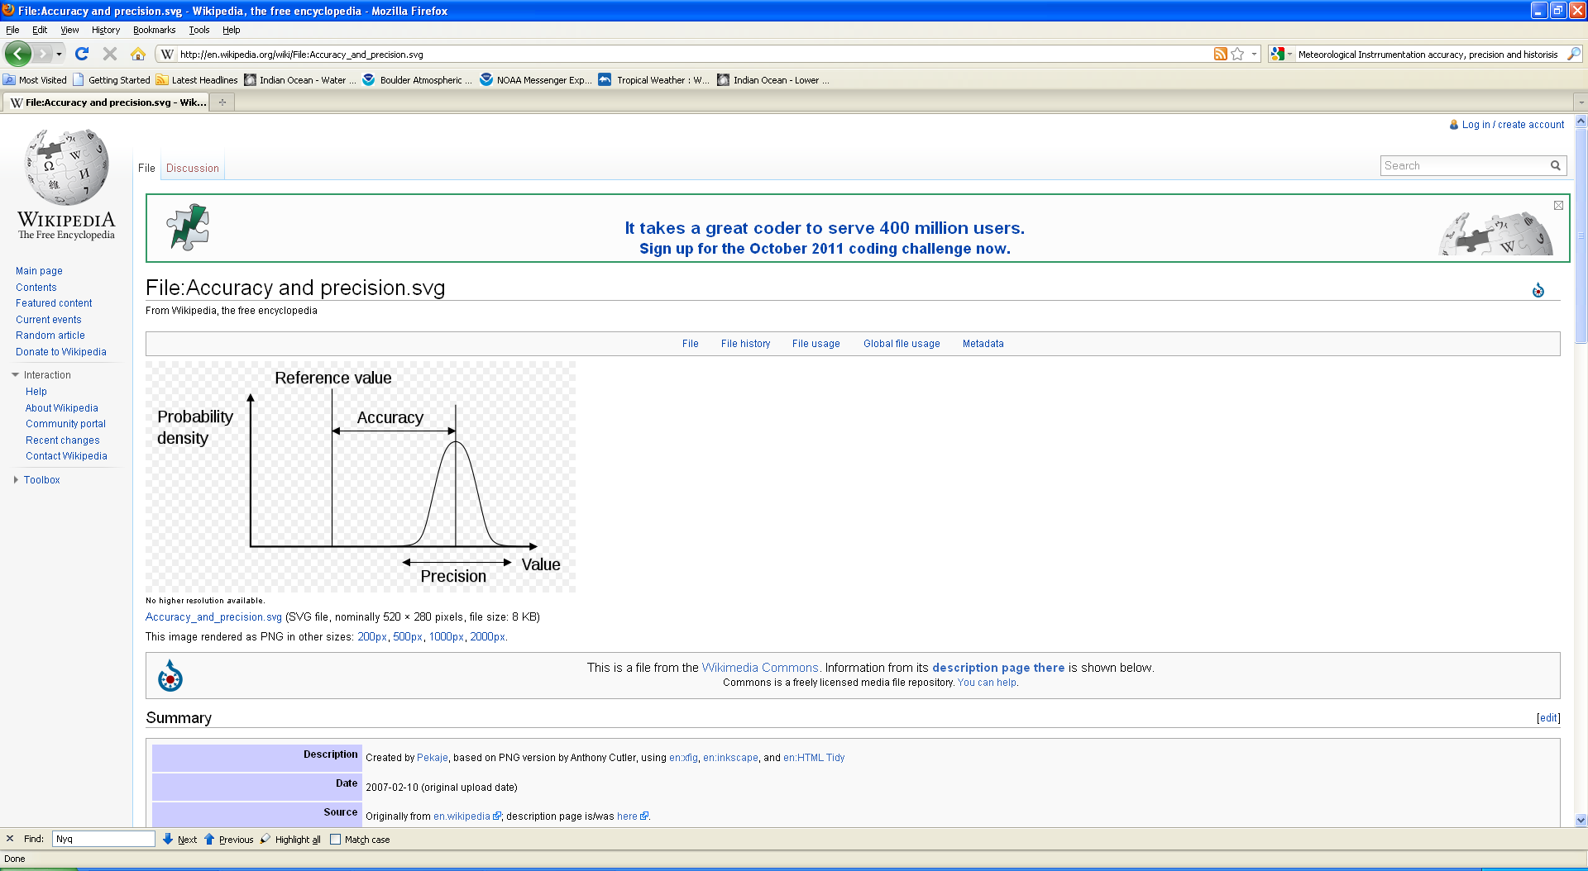 **a 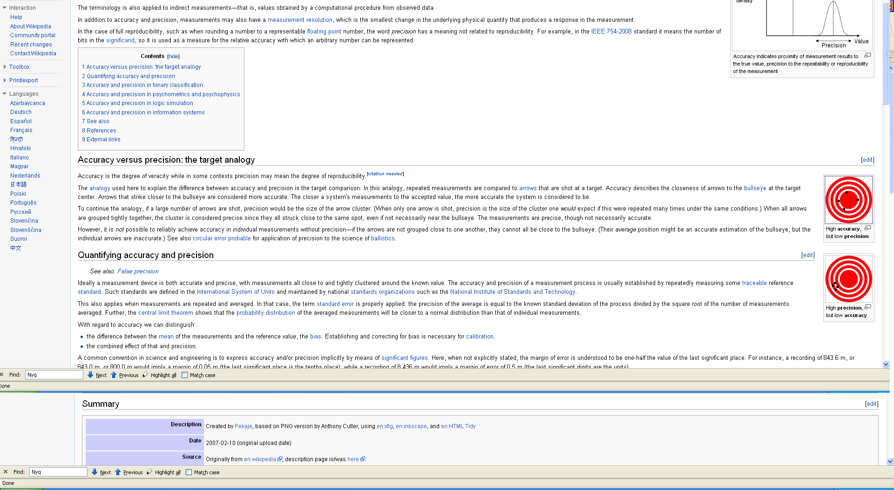b**

**Fig. 1.2.** (a) A depiction of how accuracy and precision can be quantified given a calibration reference value for accuracy and (b) two target analogies of how accuracy and precision interact.

In more technical terms, if we want to determine the value of some variable, *x*, then we perform a “measurement” with an instrument that provides an estimate of the value, *xm*. A simple method to illustrate the relationship between what we want and what we get is a linear form with a bias (offset) and a slope,

.

The bias represents a persistent offset in the device, and the (slope-1) corresponds to a persistent percentage error in each measurement. In principal, the bias and slope can be determined by a laboratory calibration and subsequently removed as a source of error by correcting the device output. To actually use the device on a ship, we ship it from the calibration facility, mount it somewhere in an environment that may be quite different (variable and influenced by flow distortion, heat islands, etc.), connect it to data-logging system, and operate it for approximately one year. Thus, the correct bias and slope corrections to be applied to this one-year record now must be considered uncertain. In many cases, we may need to apply in situ calibration or intercomparison methods to constrain these uncertainties to meet our guidelines (see Table 1).

A second aspect of measurement uncertainty must be considered when dealing with geophysical variables, which vary considerably with space and time. Typically, we are interested in *statistical* properties of the variables, such as the mean, standard deviation, or frequency spectrum. For climate purposes, the one-month average temperature at a particular location is of more significance than the instantaneous temperature at any specific time. If we now consider the variable to be a function of time, *x(t)*, then we are interested in estimating the intrinsic mean of the variable, μx, or its standard deviation, σx. At a given place and time, we can take a sample of the time series of *x* and compute the average of *x* (denoted <*x*>) over some time interval, Δ*t*.

 .

However, this particular average is only an **estimate** of the intrinsic mean—there is uncertainty in the estimate. This is analogous to asking 100 people how they will vote (a sample) to try to guess the outcome of an election. You cannot expect the 100 people you happen to poll to give exactly the same result as the 1 million that vote in the election. We can compute how uncertain our estimate of μx is by using normal statistics theory.

### Sampling

The instrument and variable you want to sample need to be matched. There are often several choices of sensor for each variable, the most suitable for a particular application depending on several factors, including the required accuracy and resolution, frequency response, and overall convenience of operation. Atmospheric variables fluctuate on time scales from below 0.1 seconds to months and on spatial scales from mm to hundreds of km (Fig 1.3).

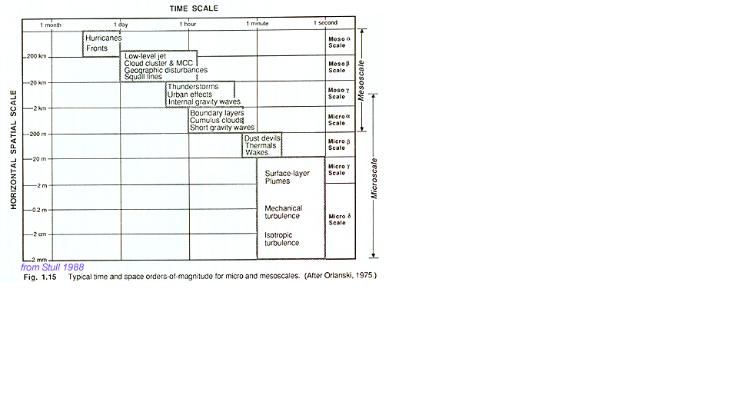

**Fig. 1.3.** Atmospheric temporal (*x*-axis) and spatial (*y*-axis) scales. We are interested in temporal ranges from below 0.1 seconds to several hours.

Note that all these scales of motion are interrelated: energy transfers or cascades from the larger scale to the smaller scales, eventually dissipating as turbulence.

Figures 1.4 and 1.5 are examples of various time scales. Figure 1.4 is the famous Keeling curve showing the change in atmospheric CO2 over the last 50 years. The red line depicts the increase in CO2, and the light gray line includes the underlying annual cycle. Figure 1.5 shows three shorter time scales: monthly, weekly, and daily.



**Fig. 1.4**. Keeling Curve showing long-term change in CO2 and the underlying annual cycle.

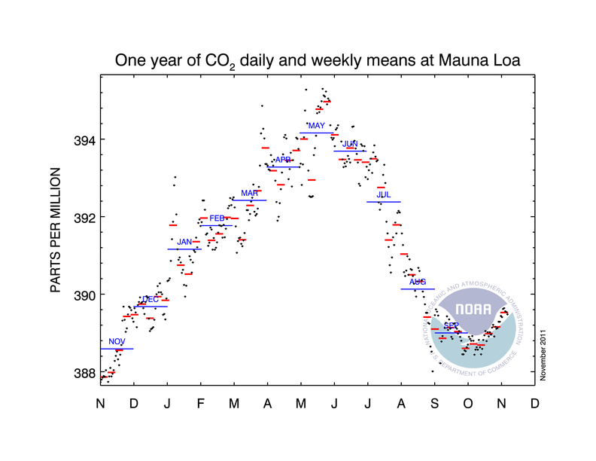

**Fig. 1.5**. One annual cycle (2010) showing the monthly, weekly, and daily averages.

Rapid sampling, typically at 20 Hz or more, is required to obtain the turbulent fluctuations of wind, temperature, and humidity for eddy correlation or inertial dissipation determination of the fluxes. These methods are not discussed in this course; instead we focus on the observations required to calculate *bulk* fluxes. A sensor responds to a step change exponentially, the time taken to reach 1-1/*e* ( ≈ 0.632) of the final value being its *time response*. By virtue of their mass, most bulk sensors have a time response of many seconds, and to avoid aliasing are sampled at about once per second. The resulting data are then time-averaged over suitable periods from a few minutes to one hour to reduce unsteadiness. We note, however, that some fast-response instruments (e.g., sonic anemometers) have become sufficiently stable that, if deployed for other purposes, they can also provide reliable long time averages. The Nyquist–Shannon sampling theorem in general states a signal can be reconstructed from its samples if the sampling frequency is greater than twice the highest frequency of the signal, also known as the Nyquist frequency.

### Oversampling is often preferred as it aids in anti-aliasing, can be used to increase resolution when using A/D convertors, and can also help reduce uncorrelated noise when averaging multiple samples.

## 1.5. Introduction to marine meteorology

The atmospheric and oceanic characteristics near the ocean surface are unique from those that exist over land and these characteristics can vary widely with latitude. Regional variations (e.g., near-western boundary ocean currents in enclosed seas [e.g., Mediterranean, Red Sea]) can also be very large. **A basic understanding of marine meteorology is integral to assessing the quality of measurements;** however, time limitations for the short course will allow only a brief introduction to some characteristics of the surface marine environment.

### Atmospheric pressure

Pressure is one of the state variables that define the thermodynamic properties of the atmosphere. Pressure at a single location varies slowly with the synoptic weather patterns (fronts, cyclones, etc). The World Meteorological Organization (WMO) target accuracy for pressure measurement is ±0.1 mb. In boundary layer and climate studies, pressure most commonly appears in the calculation of dry and moist air density (needed for air–sea flux calculation) and in humidity conversions (e.g., the psychrometer equation; see Appendix A of Bradley and Fairall 2006). Under “normal” synoptic conditions (i.e., no hurricanes or severe storms), pressure at sea level lies between about 990 and 1030 mb, with a diurnal variation (the atmospheric tide) of around ±3 mb in the tropics, less at higher latitudes. Relative to “standard” sea level pressure of 1013.25 mb, the above range typically represents a ±2% difference in air density or specific humidity. Pressure near the surface varies with height by roughly 0.1 mb per meter.

### Precipitation

Rainfall, particularly during convective storms, is perhaps the “patchiest” of all meteorological variables. Single point measurements from ships and buoys are generally less relevant for climate research than area-averaged values or spatial characteristics. Nevertheless, accurate point measurements over the ocean are invaluable for validating satellites and radar, which do obtain spatial rainfall patterns, but they must be calibrated against ground truth. Currently such validation is obtained mostly from rain gauges located on islands and atolls, where the topography has been found to distort the rainfall field.

For those seeking accurate heat fluxes, the net air–sea heat flux includes a component of sensible heat from rainfall. Heat exchange with the ocean can be calculated from the rain rate and the temperature of raindrops, usually assumed to be close to the wet-bulb temperature at sea level. In the case of tropical deep convection it has been found that raindrops are about 0.2ºC cooler than this temperature. Over extended periods, the contribution is small, but during heavy storms it can be several hundred Wm-2 and a significant component of a daily average net flux. Note that the momentum flux imparted to the ocean by raindrops may also be nonnegligible.

### Radiation

In addition to being a component of the net surface heat flux calculation, the net radiative fluxes (the difference between downwelling shortwave and upwelling shortwave radiation and the corresponding difference for longwave radiation) are also used in bulk algorithms for models of the oceanic mixed layer temperature profile and to estimate SST. For these reasons they are increasingly being measured routinely on board research vessels.

On a clear day at low and middle latitudes, downwelling shortwave radiation is the dominant component of surface heating, peaking in the vicinity of 1000 Wm-2. Therefore, any deterioration in performance of the measuring instrument can lead to significant error in determining the net flux and the thermal and density structure of the ocean mixed layer. Studies of cloud–radiation interaction, currently in their infancy, will need to distinguish between the direct and diffuse components of downwelling shortwave radiation.

Over tropical oceans, downwelling longwave radiation is determined largely by very high humidity in the boundary layer, with little diurnal variability or effect from clouds (typical values are ~350-400 Wm-2)—at higher latitudes and under clear skies, downwelling longwave radiation is significantly lower. The warm water of the tropics can emit 450 Wm-2 of thermal energy; cooler waters of higher latitudes emit correspondingly less. The difference between downwelling longwave and upwelling longwave radiation is therefore the difference of two fairly large quantities and typically of order 50 Wm-2.

### Sea Temperature

Historically, sea surface temperature was understood to be the temperature measured from a ship by whatever means available and reported as SST irrespective of the depth of measurement. We now know that temperature in the ocean surface layer can vary with depth by an amount that is significant in the context of accurate air–sea flux determination. It is the temperature of the sea–air interface itself that physically determines the magnitude of the turbulent heat fluxes and also the outward flux of longwave radiation. At the same time, these fluxes produce a cooling at the interface, the so-called “cool skin” of order 1-mm thick and typically a few tenths of °C.

In moderate to strong winds the water below the skin will be well mixed, and its “bulk” temperature will vary little in the vertical. During the day, however, penetration and absorption of solar radiation can produce a diurnal warm layer below the cool skin. Under clear skies and with light winds, as found in tropical oceans, this layer may be a few °C higher than in the bulk below. “Sea surface temperature” may thus vary with depth, as shown in Fig. 1.6; therefore, the temperature value should always be accompanied by the depth at which it was measured (e.g., SST(d) = 18.3ºC(4.5 m)).

The TOGA program specified an accuracy of ±0.3ºC for SST over a 2 x 2 degree region as a target for validation of space-borne radiometers (WCRP 1985). An error of 0.3ºC changes sensible and latent heat fluxes calculated with a bulk flux algorithm by 2 Wm-2 and 10 Wm-2, respectively, for typical climatic conditions in the tropics. The past decade has seen the development of several high-resolution infrared radiometers for shipboard deployment that achieve 0.1ºC accuracy.



**Fig. 1.6.** Profiles of sea water temperature measured during the TOGA COARE program with a near-surface undulating towed sensor, known as Seasoar. The different symbols denote the (local) time of the profile. The strong temperature increase near the surface is caused by solar heating. Later in the afternoon, the surface mixing is eroding the warm layer.

# Lesson 2: Common Sensors and Measurement Systems

NOTE: Not run at INMARTECH, but included for later reference.

Topics covered in this lesson include the following:

* Types of automated instruments commonly deployed on research vessels
* Strengths and limitations of instruments in a shipboard environment
* Examples of real-world problems that occur on ships

## 2.1. Introduction

**A wide range of automated instruments exists for making accurate measurements in the marine environment.** Note that this lesson specifically focuses on automated instruments for measuring atmospheric temperature, humidity, wind speed, pressure, and sea temperature. The term *sensor* defines the part of a measuring instrument that is directly exposed to the entity being measured, and whose characteristics respond in a predictable way to changes in that entity (e.g., resistance of a platinum wire to temperature). Other important components of the measuring system are the sensor housing and any associated electronics or recording equipment. Most automated sensors have been developed mainly for observations over land, and their use on ships and buoys has required some adaptation. At the very least they need protection from the highly corrosive environment of salt air and spray, which usually means that the housing has to be specially designed for marine applications.

There are often several choices of sensor for each variable. The most suitable for a particular application depends on several factors, including the required accuracy and resolution, frequency response, and overall convenience of operation. **Selecting the appropriate instrument for the shipboard environment is essential for making accurate marine measurements.** Atmospheric variables fluctuate on time scales from below 0.1 seconds to several hours. A sensor responds to a step change exponentially; the time taken to reach 1-1/*e* (≈ 0.632) of the final value is its *time response*. By virtue of their mass, most bulk meteorological (as opposed to fast-response) sensors have a time response of many seconds, and to avoid aliasing they are sampled at about once per second. The resulting data are then time averaged over suitable periods from a few minutes to one hour to reduce unsteadiness. We note, however, that some fast-response instruments (e.g., sonic anemometers) have become sufficiently stable that, if deployed for other purposes, they can also provide reliable long time averages.

**Obtaining a complete understanding of the ocean–atmosphere conditions at a given time around a vessel requires the collection of accurate navigational, meteorological, and surface ocean measurements. These observations need to be captured by a robust data acquisition system that provides proper time sequence and tagging for individual measurements.**

## 2.2. Wind speed and direction

For measuring average wind speed and/or direction over a certain time period, cup (or propeller) anemometers and wind vanes are usually the most convenient. Some operational designs will withstand continuous exposure to stormy conditions, but there are also more sensitive instruments intended for research work. Apart from mechanical strength, the difference is reflected in their starting speed and distance constant (response time converted to run of wind). A sensitive cup anemometer will start from rest in a breeze of 0.3 ms-1 and have a distance constant of less than 1 meter.

For best accuracy (typically 1%), cups must be calibrated individually, although data produced by instruments calibrated in a wind tunnel can be misleading when the instrument is exposed to natural fluctuating wind. In such a situation, cup anemometers usually overestimate for two reasons: the rotor responds more quickly to an increasing wind than to the reverse, and in a wind gust with a vertical component, shielding by the upwind cup is reduced. Propellers have poor response to off-axis wind direction, but this is normally overcome by mounting them on the front of a wind vane. The one instrument thus measures both wind speed and direction. Otherwise, a cup anemometer–wind vane pair is often mounted at opposite ends of a horizontal bar. Ideally, the wind direction sensor should have a complete 0-to-360˚ response. However, some instruments use a potentiometer that has a finite deadband (≤10°), in which case care must be taken to ensure that readings in this deadband are infrequent and do not corrupt the average reading. On a moving vessel, it is often best practice to orient the deadband toward the stern as the wind flow is typically from the bow as the vessel moves forward. The orientation of the zero line on the anemometer relative to the centerline of the ship is an important item of metadata to ensure correct calculation of true (Earth-relative) or ocean-relative winds.

Sonic anemometers, which are commonly used for fast-response applications in the research environment, have become sufficiently stable to enable observation of long time series. They have many advantages: they have no moving parts; they cause less distortion to the wind flow than cups or propellers; they obtain the total wind vector; some have an air temperature output. Sonic anemometers are likely to become more widely used at sea as the more robust, and less costly, models appearing on the market prove their suitability and gain acceptance.

Wind speed and direction are typically sampled together, partly because both are often obtained from a single instrument, but also because they are measured relative to the ship and must be combined with the ship’s heading, course, and speed to arrive at the true wind vector (covered in Lesson 4). The demands on accuracy of the ship’s velocity are therefore equivalent to those of the anemometer measurement. It is therefore essential to record the ship’s navigational data stream (course, heading, and speed) with the meteorological data and at a precision similar to that of the wind observations.

For air–sea flux (as opposed to mean meteorology) applications, the appropriate wind speed to use in bulk flux algorithms is that which is relative to the ocean surface (i.e., taking into account the surface current). This introduces another source of uncertainty because the water velocity at the interface itself is very seldom measured. There are two ways in which conversion from relative to true wind can account for the surface velocity: (1) by combining the ship motion in Earth coordinates (e.g., from GPS) with currents from the ship’s ADCP or (2) by using the Döppler-log/gyro, which measures the ship’s motion through the water. Data reports should indicate which method has been used; both incur additional sources of instrumental error, and furthermore, the measured currents are at considerable depth (of order 10 m). Fortunately, in many cases current is a small fraction of the wind speed, so its contribution to the error is also small; however, in light winds it can be significant.

## 2.3. Atmospheric pressure

Modern aneroid barometers with a digital readout have a resolution of 0.1 mb and are relatively stable, but they require checking against standard instruments from time to time. More commonly, research and climate applications require recording of continuous time series of pressure, and solid-state sensors with high resolution and long-term stability of 0.1 mb are now available.

It is not uncommon for the pressure sensor to be located on a ship’s bridge or in a dry lab, but it can also be mounted on an external instrument mast. When the barometer is inside, it is important to ensure that the pressure port is in a location that measures the pressure outside the vessel and avoids dynamic pressure fluctuations due to the wind. Special inlet ports designed to overcome dynamic pressure fluctuations from the wind are available for connection to the barometer via a plastic tube. If inside, the sensor must be located in a space that is not pressurized by, for example, the ship’s air conditioning.

## 2.4. Air temperature

Automated sensors commonly used to measure atmospheric temperature are thermocouples, platinum resistance thermometers (PRTs), and thermistors. Thermocouple systems have the disadvantage of low output voltage and for absolute measurement require a reference “cold” junction. Good-quality PRTs are very stable, and with careful calibration, accuracy of about 0.01°C can be achieved, although their typical resistance of 100 ohms requires a high-resolution resistance bridge. PRTs are the temperature sensors most commonly used in high-quality commercial instruments. Both thermocouples and PRTs can be easily configured for differential measurement, which can improve the measurement accuracy of the wet-bulb depression when they are used in a psychrometer (see next section).

Thermistors are semiconductor devices with much higher resistance values (typically 3000 ohms) than PRTs, making the measurement of resistance changes easier. Unlike the linear response of PRTs, the larger signal comes at the expense of nonlinearity. Formerly, they were prone to uncertainties of stability and calibration, but guaranteed interchangeability of ±0.1°C is now available from some manufacturers, and microprocessor technology enables their logarithmic response to be linearized.

The most usual causes of error in air temperature measurement are sources of anomalous heating: the sun and the ship. The temperature sensor is often installed in an enclosure that shades it from the sun but which relies on natural ventilation, i.e., through slots in the sides of the enclosure, as shown in Fig. 2.1 (left). These may be effective in overcast conditions or strong winds, but in light winds and strong sun, the temperature in such a simple housing has been shown to rise several degrees above the true air temperature. To achieve the accuracy cited in Table 1, the sensor element must be within a specially designed shielded and ventilated enclosure such as the one illustrated in Fig. 2.1 (right). Even such an arrangement is ineffective if the system is poorly located. The ship itself is a massive source of heat, and almost any location aft of the bow will measure air that has passed over some area of warm steel.

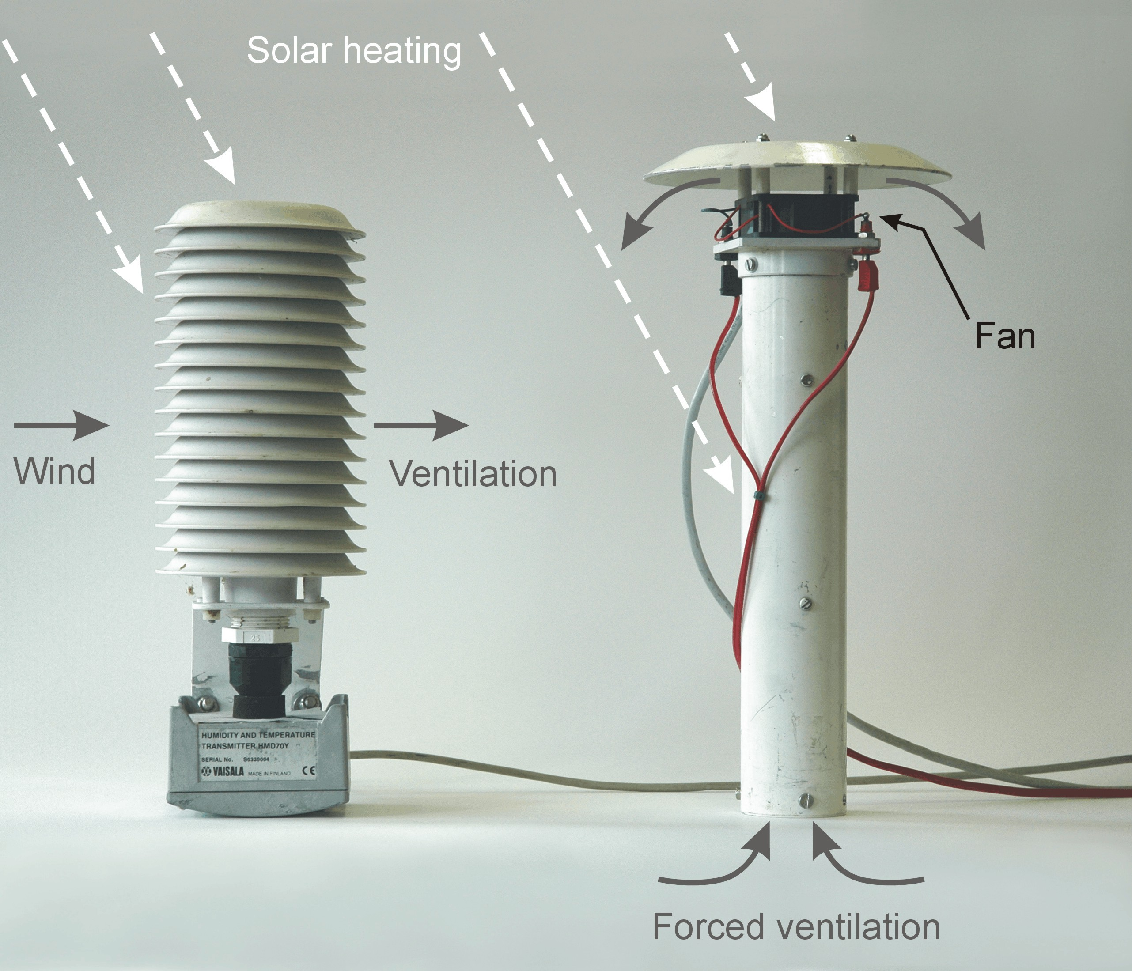

**Fig. 2.1.** Temperature/humidity screens; left with natural ventilation; right with double screening and forced ventilation.

Experiments that rely on continuous and accurate measurement of air temperature (and other meteorological quantities) will often duplicate instrument packages on port and starboard, taking data from the sensors most favorably exposed to the wind. Even so, the wind will sometimes be directly over the stern of the ship and the data will have to be discarded. Therefore, relative wind direction is a critical part of the data record.

## 2.5. Humidity

Atmospheric humidity is variously specified by the partial pressure of water vapor (*e*, mbar or equivalently hPa), vapor density (*ρv*, gm-3), specific humidity (*q*, g/g of moist air), mixing ratio (*rv*, g/g), or relative humidity (*RH*=100 *e*/*es*) where *es* is the saturation vapor pressure at air temperature *Ta*. At a particular ambient humidity, reducing air temperature reaches the point where *e* equals *es*. This is known as the dewpoint *Td*. Formulae to convert between these various definitions of humidity are given in Appendix A of Bradley and Fairall (2006), as are empirical equations for *es* as a function of *Ta*.

The traditional instrument for atmospheric humidity measurement is the psychrometer, consisting of a pair of thermometers, one of which is covered with a moist wick. Air drawn over the thermometers evaporates the moisture, cooling the wick until the evaporation rate is in equilibrium with the atmospheric water vapor. This wet-bulb depression is understood from thermodynamic theory and is described by the psychrometer equation given in Appendix A of Bradley and Fairall (2006).

For automatic data logging, psychrometers can be constructed using either PRTs or thermocouples as the sensing elements. Accurate measurement requires shielding from solar radiation and adequate airflow over the thermometers to ensure full wet-bulb depression. This is best achieved by using a double heat-reflecting shield, as illustrated in Fig. 2.1 on the right, with the air drawn over the top and through the space between the shields at a rate of at least 4 m s-1. With PRTs in a differential bridge, temperature resolution of ±0.01°C and, with care, specific humidity accuracy of 0.05 g kg-1, are possible.

Thin-film polymers that absorb or desorb water as the relative humidity changes are the most common humidity sensors currently used on research vessels at sea. Early versions of these sensors often failed at very high humidity, but recent developments have largely overcome this problem and improved the accuracy and stability of calibration. The polymer usually forms the dielectric of a capacitance in a circuit that provides an electrical output proportional to relative humidity. Conversion to mixing ratio or to specific or absolute humidity requires measuring the temperature of the air surrounding the dielectric, often using a collocated PRT. The best quoted accuracy is ±2% *RH* (or ±0.3 g kg-1 at 20°C and 70% *RH*). For accurate measurement these temperature–*RH* sensors, like the psychrometer, are ventilated and screened. There is also a Gortex® filter around the sensing element that must be changed or washed to remove salt.

The dewpoint hygrometer incorporates a mirror that is maintained, by optical and electronic feedback, at the temperature, *Td* , where moisture or ice just condenses on its surface. The dewpoint can be converted to any of the other humidity units using relationships outlined in Appendix A of Bradley and Fairall (2006). The dewpoint hygrometer is an absolute instrument, not well suited for operational use at sea, but it is often carried as a secondary standard to calibrate other sensors. Best quoted accuracy for a dewpoint instrument is ±0.2°C, which converts into an uncertainty in *RH* of ±1%.

Some sensors are more suited to use at sea than others and most need periodic maintenance to remove salt deposited on the sensor or on the filter provided to protect the sensor. Some systems combine air temperature and humidity sensors in the same package, so they are subject to the same requirements for ventilation and screening from solar heating. Conversion between some forms of humidity, for example from *RH*, requires the temperature of the air surrounding the humidity sensor. Since water vapor is a conservative quantity, the corresponding error in the water vapor measurement is less severe than an error in temperature when the latter is obtained from the collocated sensor.

## 2.6. Precipitation

Traditional rain gauges measure the rain falling into a funnel of known area. For automatic recording, either a weighing system or a tipping-bucket rain gauge, for which the funnel discharges to a pair of buckets in a “see-saw” arrangement that flips over at every 0.1 mm of rainfall, is used. Neither of these methods is feasible on the unsteady platform of a ship or buoy. The most common rain gauge in this case is the siphon gauge. The funnel discharges into a reservoir that fills to capacity (about 50 mm of rain), then the instrument siphons automatically and the reservoir starts filling again. An electronic sensor keeps track of the level of water in the reservoir.

Rain gauges used at sea must handle rain rates up to around 200 mm hr-1, which would be an extreme tropical storm. A heavy rainstorm in the midlatitudes might produce instantaneous rain rates of 50 to 100 mm hr-1, but more commonly, rain rates are between 1 and 20 mm hr-1. All funnel gauges lose catch in strong winds, when the gauge deflects airflow so raindrops are carried past the funnel. This phenomenon is exacerbated at sea by wind flow distortion over the entire bulk of the ship. The siphon gauge also misses rain while the instrument is siphoning. A rain gauge intended to overcome both problems has been developed by the Oceanographic Institute at Kiel, but is not yet fully proven (Hasse et al. 1998).

Optical rain gauges (ORGs) measure *rain rate* by detecting raindrops falling through an optical path. One system measures extinction of a light beam by the raindrops; another measures the intensity of scintillations caused by raindrops passing through the semicoherent infrared beam from a light-emitting diode. Rainfall amount is obtained by integrating the rain rate. ORGs must be calibrated against a funnel gauge in natural or simulated rainfall. Their main drawback is that the light path has a particular (and arbitrary) direction relative to the rainfall, whose vertical component is thus uncertain. Some indication of errors due to this uncertainty may be obtained by mounting two ORGs orthogonally (Fig. 2.2).

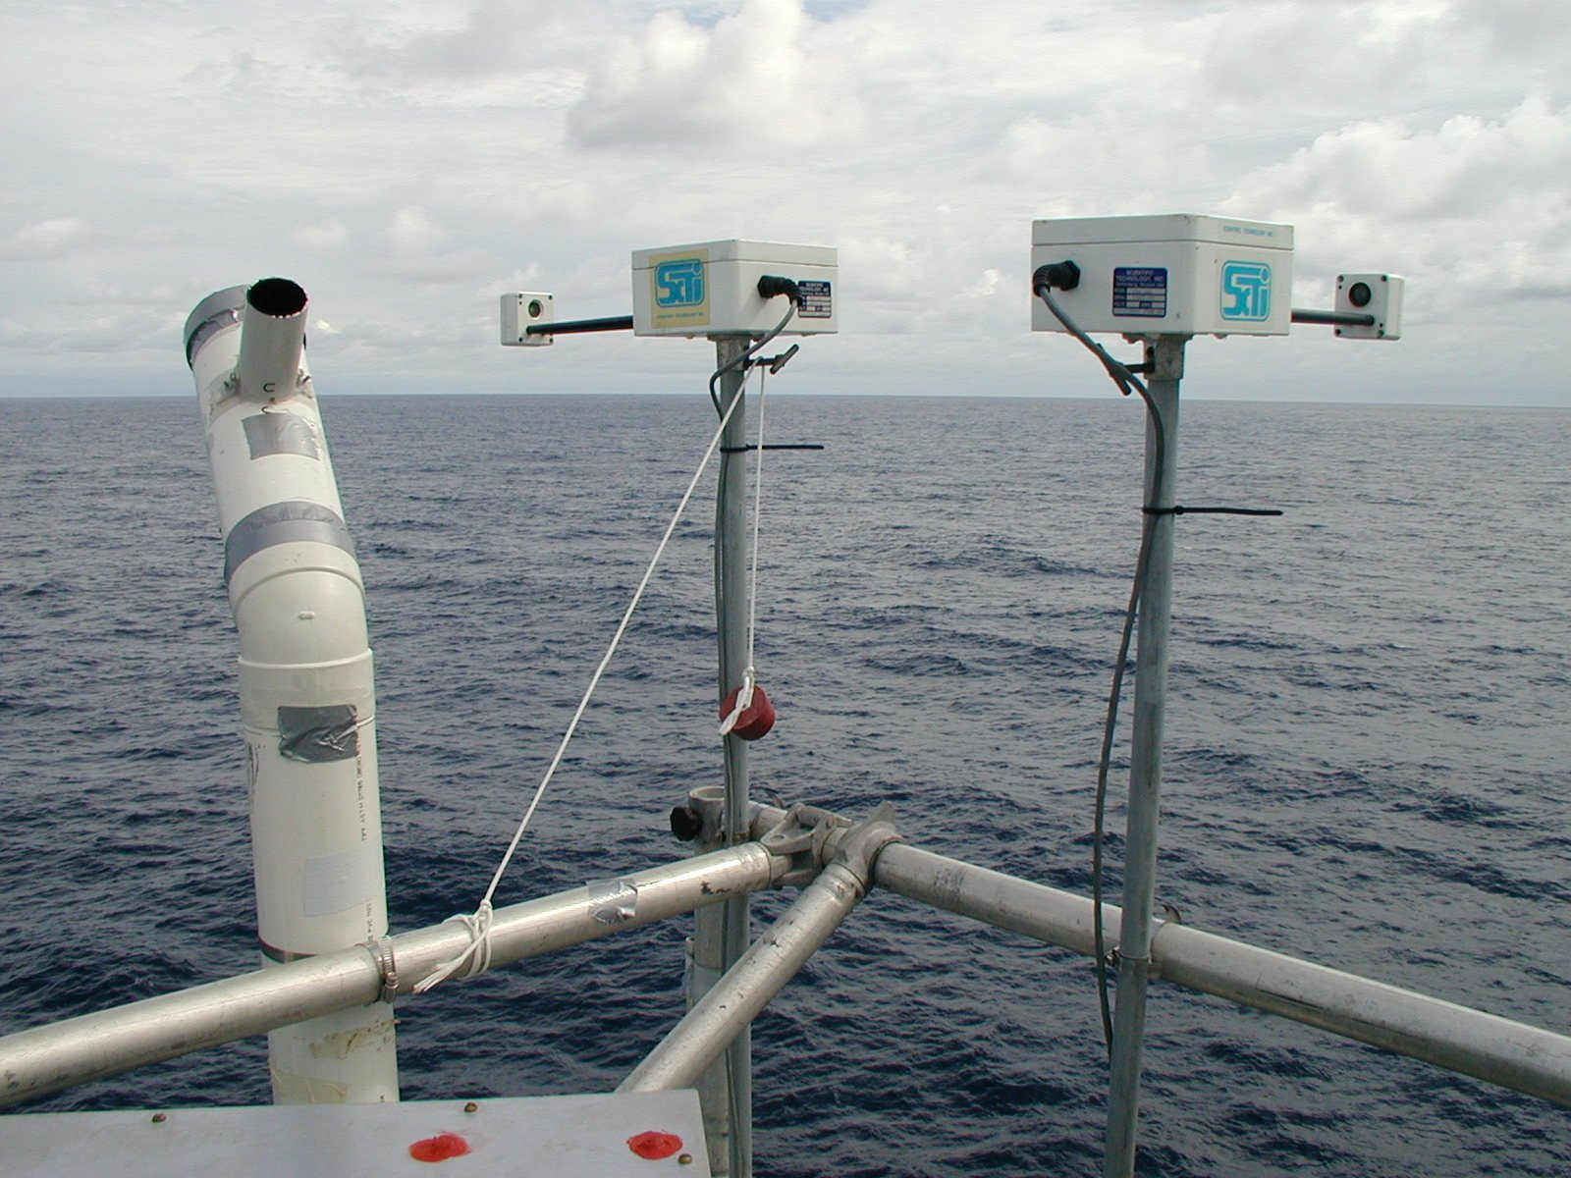

**Fig. 2.2.** Example deployment of optical rain gauges. A pair of sensors is mounted with their axes oriented at 90º to each other. This geometry helps with the wind correction procedure.

Disdrometers are primarily intended for the measurement of drop size and drop distribution in rainfall. The most usual is an acoustic device that converts the sound of the impact of raindrops hitting the sensor surface into an electrical signal related to the size of the drop. Continuous recording of the size and number of drops provides a time series of rain rate and total rainfall by integration. Disdrometers are still regarded as a research tool and are seldom used operationally on ships. Some all-in-one meteorological sensor packages (e.g., Vaisalla WXT) do include a precipitation option from a disdrometer; however, these sensors have undergone limited testing in a shipboard environment.

The main problem in measuring rainfall from ships (and to a lesser extent from buoys) using the traditional funnel gauge is error due to wind flow distortion that can lead to underestimation, depending on the location of the gauge. The problem has been studied, using an array of gauges distributed around the ship, and correction schemes have been devised that can improve the accuracy of rain measurement to within 10-15%, as shown in Fig. 2.3. Operationally, it is important to ensure the rain gauge is well exposed and near the location where relative wind speed and direction are recorded. A well-positioned gauge adjacent to a wind instrument is better than several gauges scattered around the ship. 

**Fig. 2.3.** Cumulative rainfall measured by optical and funnel rain gauges on a ship, before and after wind correction. The ORGs overestimate slightly when the raindrops are blown through the optical path at an angle to the vertical (dark and light blue traces). Siphon gauges underestimate when strong winds are distorted up over the ship and deflect raindrops away from the funnel (dark and light pairs of red and green traces). The black curve is the relative wind speed. Rainfall events started around days 264.4, 265.7, 266.6, and 267.3.

## 2.7. Radiation

Because of its dominant role in Earth’s energy budget, much attention has been given to the study of solar and terrestrial radiation components and their intensity, spectral characteristics, and distribution. As a result, accurate instruments and methodology have evolved, often requiring precise directional pointing, meaning that they can be operated only from a completely stable platform. This requirement precludes their routine deployment from ships and moorings. The following describes instruments currently suitable for marine studies.

Downwelling shortwave and longwave radiation are measured with a pyranometer and a pyrgeometer, respectively. These instruments are physically similar, both accepting broadband, whole-sky radiation through a hemispherical dome with the relevant spectral transmission characteristics (Fig. 2.4). Solar radiation passing through the glass dome of the pyranometer impinges on a flat thermopile with a blackened upper surface. The instrument is so constructed, using two concentric domes to overcome convection within the instrument, that the thermopile output has a linear response to the radiative intensity. Accuracy of the instrument is usually quoted as 2%. The pyrgeometer works by determining its own thermal balance, combining the contributions from dome and case temperatures with voltage derived from longwave radiation passing through the silicon dome and detected with a thermopile. There are thus three output signals to be recorded and combined externally using the pyrgeometer formula (see Appendix A of Bradley and Fairall 2006). An alternative method provided by the manufacturer, using an internal compensating circuit to provide just a single output signal, is to be avoided since it severely degrades the potential accuracy of the instrument from about 3% to worse than 20%. Both radiation instruments are vulnerable to the many sources of electromagnetic interference aboard ships, since the domes leave the thermopile unscreened. Pyrgeometer domes also suffer from problems of shortwave leakage.

Ideally, both instruments should be in a location with an unobstructed horizon-to-horizon view in any direction, but on a ship it is virtually impossible to avoid shadowing of the instruments while still maintaining accessibility for maintenance. At sea, the domes become contaminated with salt and soot and need frequent washing. The shadowing problem means that the pyranometer location is usually a compromise. The instruments shown in Fig. 2.4 are quite well exposed at position G (see Lesson 3, Fig. 3.1) and duplicated for increased reliability. In less favorable exposure, the pairs can be separated far enough to avoid their being covered simultaneously by the same shadow. If the relative locations are carefully documented, shadows can usually be diagnosed and flagged by a user or a data center during postprocessing of the data record. In the case of pyrgeometers, the effect of IR flux contamination by objects in the field of view is also a concern and details can be found in Appendix C of Bradley and Fairall (2006).

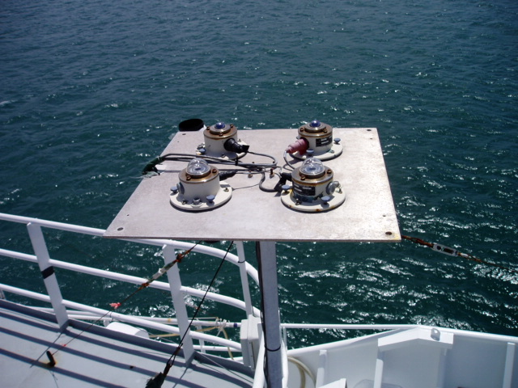

**Fig. 2.4.** Example of duplicated pyranometer and pyrgeometer sensors mounted on a ship at position G (see Fig. 3.1).

Platform motion is also a potential source of error when radiation instruments are used at sea. For correct measurement, the instruments must be horizontal, but ships and buoys can roll through several degrees or take on a systematic lean caused by wind force or poor trim. The severity of the error depends not only on the inherent stability of the particular platform but also on factors such as cloudiness, latitude, season, and time of day. The error is less severe for the pyrgeometer, since any sea in the field of view will be close to the near-surface air temperature. A possible solution is to set the instruments on gimbals but, unless very carefully designed, gimbals introduce other problems due to damping and phase variations. The better arrangement would be a dynamic system, such as a servo-controlled platform whose stability is achieved by feedback from a motion sensor, but so far such an arrangement is available only in limited research applications.

Regular dome cleaning may not be sufficient to overcome erroneous measurement. A recent observation of condensation on the inside of a pyranometer dome, despite the provision of a desiccant within the instrument, was found to reduce the output by about 100 Wm-2. The probability that this phenomenon would be noticed is small because the instruments are usually mounted well above eye level. This example prompts the question of whether condensation inside the domes of pyrgeometers may be the cause of anomalous signals found with those instruments also. Because of the interference filter deposited inside pyrgeometer domes, condensation would not be seen, but it might be suspected if condensation were found in an adjacent pyranometer.

## 2.8. Sea surface temperature

Automated recording of sea temperature on research vessels is often accomplished using a thermosalinograph (TSG) that measures the temperature of engine cooling water near the intake port. The basic accuracy of the instrument is a few 0.001ºC. When the flow to the TSG is sufficiently large, spurious heating from inside the ship does not significantly alter the measured temperature (depending on the length of pipe run from the intake to the TSG). The depth of the intake is known but it is usually well aft. It has been found that, because of the pattern of flow along the hull, the water entering the intake may have originated from some shallower depth ahead of the ship. With a well-mixed surface layer, at night for example, the difference may be small, but in daytime if there is a significant vertical temperature gradient near the surface due to light winds and solar heating, it can be several tenths of a degree.

A better arrangement is the thermosalinograph having its own intake port and pump near the bow of the ship. There is still some uncertainty about the effective depth of measurement, particularly with the ship pitching in heavy seas when there is also the danger of the intake breaking the surface. Often the thermosalinograph is turned off in port and in some coastal conditions to prevent fouling of the sensors by oil and other contaminants.

Another class of sensors is attached inside the hull of the ship and these sensors measure some sort of average temperature over the surface layer, providing they are located well below the water line. These sensors are not as sensitive as those in direct contact with the water because their signal is damped through the vessel hull. They must be exposed to the external hull plating and should be insulated from the internal vessel air temperature.

Some research cruises measure sea temperature close to the surface by trailing a sensor (usually a thermistor) mounted at the end of a length of plastic hose or a rope with an internal conductor. One type is known as a “Seasnake.” It is towed from a light boom near the bow of the ship and extends as far out as practicable, preferably outside the bow wave. Underway in slight seas, the hose will follow the surface at a depth of 5–10 cm, but in heavier seas it will often become airborne. This can be overcome to some extent using streamlined weights. Comparisons with ships’ thermosalinographs at night, and when the surface layer is well mixed to a considerable depth, indicate that the Seasnake is capable of 0.1ºC accuracy. During the day the Seasnake captures nearly all the daytime surface warming but does not measure the cool skin regime because the sensor is below this layer. In persistent stormy conditions the Seasnake may have to be brought inboard and stowed to prevent its destruction. When the ship stops, the Seasnake normally sinks, even if it is not weighted, but in any case, under these conditions the ship contaminates the water temperature.

During the past decade, a number of high-resolution infrared (IR) radiometers have been developed for use at sea. This instrument is normally mounted forward on a side rail of the ship, high enough to view the sea surface outside the bow wave. Its view is a narrow cone operating within spectral bands in the range 8–12 µm, similar to the channels of space-borne IR radiometers. The view angle to the undisturbed surface will depend on the geometry of the ship, and is usually between 30º and 60º to the vertical. SST is obtained from the measured radiance and surface emissivity, which is a function of view angle, and a correction is made for reflected sky radiation using a second radiometer pointed skyward at the same angle (which is covered during rain). Depending on sky conditions and atmospheric water vapor content, this correction can vary from near 0 to at least 1ºC. Some instruments self-calibrate the radiometer sensor using internal blackbody targets at different temperatures. The most sophisticated examples of this type of instrument claim SST accuracy of 0.1ºC.

# Lesson 3: Sensor Location and Exposure

Topics covered in this lesson include the following:

* Location of sensors to allow optimal exposure for measuring the desired atmospheric phenomena
* Strategies to minimize the impact real-world obstacles on ships have on the quality of collected observations

## 3.1. Introduction

**Location of the sensors on the ship is the most critical aspect for accurate measurement of the basic meteorological variables.** The particular difficulties of making these measurements aboard a ship include

* alteration of airflow by the vessel structure prior to air reaching the sensor (known as flow distortion);
* exposure of the sensor to sea spray, salt contamination, and vessel exhaust; and
* vessel motion influencing collected data.

Ideally, sensors should be exposed to the air before it flows over the bulk of the vessel’s decks and super structure. Meteorological instruments should be located forward on the ship, ahead of the engine and air-conditioner exhausts. The ideal position is high on a forward mast, high enough to be above spray when the ship pitches in heavy seas. Because ships are of various shapes and sizes and have different appendages, such decisions must be made on a ship-by-ship basis. However, there are principles, mostly based on common sense, which can help minimize defective observations. They are illustrated in relation to typical ships in Fig. 3.1.

## 3.2. Temperature

The temperature sensor should be as far forward as possible to avoid heat contamination from the ship. Avoiding heat contamination is impossible when the wind is from astern, so having duplicate sensors to port and starboard is one solution to provide better data recovery. The temperature sensor should be shielded and ventilated, but care must be taken to ensure that there is no possibility of sea spray being drawn into the air inlet. Although the mainmast may have a well-exposed site for wind instruments and be clear of sea spray, it is usually a poor location for temperature sensors that can then “see” large areas of the (often warm) deck.

## 3.3. Humidity

The measurement of water vapor is little affected by wind and thermal distortion caused by the ship. It is important that the temperature of air surrounding the sensor is recorded, and since the two measurements are commonly made in the same package, the more stringent exposure requirements of the temperature sensor ensure that the humidity sensor is also well exposed. The location must, however, permit access to the humidity element for periodic maintenance. If a psychrometer is being used, it will also be necessary to top off the water reservoir with distilled water from time to time.

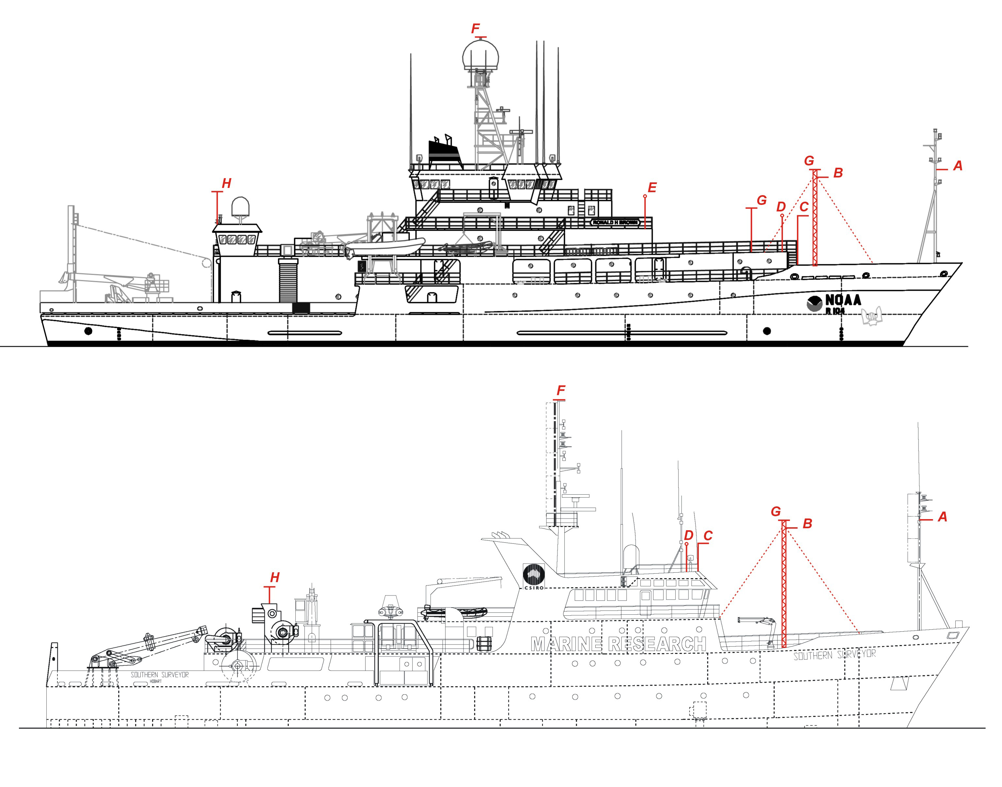

**Fig. 3.1.** Examples of ships with good foremast locations for instruments: R/V *Ronald H. Brown* (NOAA) and R/V *Southern Surveyor* (CSIRO). Locations suggested for different types of meteorological sensors include (A) foremast, (B) foredeck lattice mast, (C) pole above the wheelhouse, (D, E) port and starboard locations for redundant sensors, (F) top of mainmast, (G) top of foredeck mast, and (H) top of doghouse or aft crane shack.

## 3.4. Wind speed and direction

The most important requirement of the wind sensors is that they should have no obstruction upwind. A single speed/direction set can be mounted on a forward-facing arm from a foremast or high on the mainmast. With only one set of instruments, there will always be a sector astern over which the relative wind will be in error. If two wind sets are available, it is good practice to mount one on each side of the ship and give preference to whichever has the best exposure to the relative wind.

Note that even an object located **behind** the anemometer will cause some disturbance to the wind, the error scaling with the size of the object. Thus, high on the top of a mast or pole is a good location for mounting a sensor. If mounted on an arm facing forward from the mast, the sensor should be at least five mast diameters forward. However, a horizontal boom in front of the bow is not a good place because, with the bulk of the ship behind, it is not possible to go far enough forward to measure undisturbed flow.

## 3.5. Sea temperature

The location of a ship’s thermosalinograph and its inlet port are usually outside of the investigator’s control. Ideally, the inlet port should be in the bow at sufficient depth (e.g., about 5 m) so that it does not break the water surface in heavy seas. Similarly, a hull sensor should be mounted inside the bow. A Seasnake-type sensor should be towed from a point as far forward and as far out as practicable so that the sensor will spend much of its time outside the ship’s bow wave. For the same reason, infrared radiometers for SST measurement, when available, are mounted as far forward and as high as possible (on the wheelhouse roof for example) so that their view is of an undisturbed ocean surface.

## 3.6. Radiation

Upward-facing radiometers need an all-round, horizon-to-horizon view with minimal obstruction by parts of the ship, which will cast shadows on the pyranometer and be a source of thermal radiation for the pyrgeometer. Possible locations are the top of the mainmast or foremast, providing they are accessible at sea under moderate weather conditions so that the domes can by cleaned periodically and the desiccant replaced. In some cases water jets, controlled from a convenient tap on the deck, have been used to successfully clean domes, eliminating the need to climb an instrument mast at sea. The pair of instruments is normally mounted together on a single aluminum plate and leveled. If the mast proves impractical, the plate can be mounted on the top of a rigid galvanized metal pipe (e.g., a scaffolding tube or thick water pipe), clamped in some way to a convenient rail, perhaps above the wheelhouse.

Shadows can often be diagnosed by installing a second pyranometer, separated widely enough from the first that they are not covered by common shadows. Both pyranometers and pyrgeometers are “cosine” detectors, so objects near the horizon have a much smaller effect than objects overhead. Details on the error in a pyrgeometer measurement when it receives thermal radiation from parts of the ship unavoidably in its field of view can be found in Appendix C of Bradley and Fairall (2006).

## 3.7. Rainfall

The difficulties of making accurate measurements of rainfall on ships, and the strong dependence on location of the instruments, have been described in Lesson 2. Funnel gauges should not be mounted in a location of strong updrafts, such as on a rail just above the side of the ship or above the wheelhouse, where they will lose catch. Rain gauges located on the aft part of the ship may overestimate by catching water that has accumulated on the superstructure. Once again, the best location is on a foremast. If that becomes too crowded, a position on the foredeck near the centerline of the ship will help avoid updrafts.

Because wind information is used to correct both funnel and optical rain gauges, a location near the wind sensor is preferred.

## 3.8. Strategies to limit observational errors

**The first consideration for any instrument deployment is that sensor location and exposure will be a compromise between the scientifically “best” location for the sensor and the operational realities on board a vessel.** For example, placing the radiation sensors at location F (Fig. 3.1) will provide the best shade-free view of the entire sky above the vessel; however, this location will be difficult to access for sensor cleaning and repairs (especially during a cruise). Therefore, the compromise location H may be preferred to allow access while at sea, but the technicians must be aware that a more frequent cleaning schedule may be needed since the sensor is now located aft of the vessel exhaust stack.

As noted above, deploying redundant sensors can allow the selection of data from the sensor that is best exposed to the vessel-relative wind flow. Deploying sensors to port and starboard on the main mast is one option, as is deploying one sensor set on the mainmast and one on the foremast. To best use the redundant measurements it is essential to record details on the differing sensor heights and distances to the port/starboard of the mast on which they are deployed. Even redundant sensors will not compensate for all airflow problems, as they will be subject to some distortion from their mounting mast, other sensors, or antennas.

The critical detail for the operator and technician to consider is how to minimize the potential exposure errors.

# Lesson 4: Adjusting Observations for Ship Motion and Sensor Height

Topics covered in this lesson include the following:

* Adjusting wind observations to account for ship course, heading, and speed
* Common height adjustments for atmospheric observations

## 4.1. Introduction

Working with underway meteorological observations on a moving platform introduces several complications. Anemometers measure the wind speed and direction relative to the vessel, but most users want the wind direction/speed relative to the fixed Earth (true wind) or the ocean surface. This requires vessel operators to include conversion codes that combine navigational data with the vessel-relative winds to provide the wind in the desired reference frame. Another common correction is the reduction of the atmospheric pressure observation from the observation height down to sea level (the standard required for use by national meteorological centers). Although not essential (if the barometer height is recorded with the data), the sea level pressure adjustment is a common conversion. Finally, the variation of winds, air temperature, and humidity with height above the ocean surface is provided, since a wide range of applications require measurements to be adjusted from observation height down to common reference heights (e.g., 10 m for winds, 2 m for air temperature and humidity). An introduction to the latter height adjustments is included for completeness, although secondary data users (researchers), not the vessel technical staff, commonly perform the adjustments.

## 4.2 Wind adjustments for vessel motion

In this lesson the focus is on adjusting wind direction and speed measurements made relative to the vessel to create Earth-relative or ocean-relative winds. These calculations account for the vessel’s course over the ground (or water), speed over the ground (or water), and vessel heading. The lesson will not cover adjustments to account for vessel pitch, roll, or heave, although compensating for these motions is essential when the user is interested in winds for direct flux measurement at high sampling rates (greater than one hertz).

Conversion of relative to true wind speed and direction

The procedure to calculate a true wind using the vessel’s course and speed over the ground, heading, and platform-relative winds is outlined in Appendix A (<http://coaps.fsu.edu/woce/truewind/paper/>) of Smith et al. (1999).

Note: The calculations in Smith et al. (1999) use angles that are expressed in degrees. Some computer software requires that angles be expressed in radians, and entering degrees can generate bewildering results. If radian input is necessary, angles should be multiplied by the factor *rdcon* = *pi*/180 (*pi* = 3.14159).

Conversion of relative to water-relative wind speed and direction

Certain applications, in particular air–sea flux calculation, require the wind speed relative to the surface water. We call this the “water-relative” wind. When the near-surface current speed and direction (Earth relative) are available (e.g., from a surface mooring) this current can be resolved into north and east components *cn* and *ce*. These would normally be in the oceanographic convention “to.” Then, having acknowledged this convention, the true wind components can be converted to water relative, and the water-relative wind speed *uw* = [(*un*+*cn*)2 + (*ue*+*ce*)2]1/2, which is equivalent to (*uz* – *u0*) in equation (11.7) in Bradley and Fairall (2006).

Alternatively, *uw* may be obtained by replacing *cog* and *sog* with course and speed from the ship’s 2-axis Döppler-log and gyro-compass, as follows:

*uf* = forward speed from Döppler-log

*us* = side-slip to starboard (positive)

*head* = gyro-compass heading, north = 0° east = 90°

*rels* = relative wind speed

*reld* = relative wind direction, 0° over bow, 90° over starboard

*relsn* = *rels* × cos(*head*+*reld*) northerly component of relative wind (as before)

*relse* = *rels* × sin(*head*+*reld*) easterly component of relative wind (as before)

*sown* = *uf* × cos(*head*)-*us* × sin(*head*) north component of ship speed

*sowe* = *uf* × sin(*head*)+*us* × cos(*head*) east component of ship speed

*unw* = *relsn*-*sown* northerly component of water-relative wind (-ve sign, wind dir. “from”)

*uew* = *relse*-*sowe* easterly component of water-relative wind

(-ve sign, wind dir. “from”)

*dirw* = mod(atan2(*uew*,*unw*)+360,360) water-relative wind direction

*uw* = (*unw*2 + *uew*2)1/2 water-relative wind speed, where again,

*uw* is equivalent to (*uz* - *u0*) in equation (11.7) in Bradley and Fairall (2006).

The above comments regarding the mode of angles and use of atan2 apply.

The challenges associated with calculating true winds are discussed in considerable detail by Smith et al. (1999). Program codes for calculating true (Earth-relative) winds can be obtained from <http://samos.coaps.fsu.edu/html/tools_truewinds.php>.

## 4.3. Common height adjustments to atmospheric observations

### Barometer correction

Near the surface, atmospheric pressure falls at about 0.12 mb m-1 as height increases. Since we need the value near the surface and the barometer is usually on the bridge some tens of meters higher, we make a correction based on the hydrostatic equation for the atmosphere,

,

where *z* is height, *p* is pressure, and *g* is the acceleration due to gravity. Introducing the ideal gas law and integrating this expression from observation height to the surface and simplifying, we have for the surface pressure

*ps* = *p*exp(*gz/RaT*),

where *p* is the observed pressure at height *z*, *Ra* is the gas constant for dry air, and *T* (K) is a reference temperature (e.g., at *z* = 10 m). For example, if the pressure at a barometer height of 30 m was 1000.0 mb, with *g* = 9.81 m s-2, *Ra* = 287.05 J kg-1 K-1, and *T* = 290 K, *ps* = 1003.54 mb.

### Winds, air temperature, and humidity

This portion of Lesson 4 focuses on reasons to height adjust wind, air temperature, and humidity data. The methods for these adjustments are covered in Bradley and Fairall (2006) and are beyond the scope of this training.

The variation with height of wind speed, temperature, and water vapor content in the atmospheric surface layer (their profiles) depends on surface conditions and thermal stability, as described in section 11 of Fairall and Bradley (2006). There are two main reasons for needing to estimate the value of any of wind, water vapor, or temperature at a height other than that at which it was measured: (1) adjustment to standard reference height (10 m) to relate your vessel’s observations to those from other experiments (e.g., comparing 10-m ship winds to 10-m satellite winds) and (2) to compare observations from instruments at different heights either on your vessel or between different platforms (e.g., ship winds at 20 m to mooring winds at 2 m).

For example, the profiles shown in Fig. 4.1 are derived from meteorological data obtained from the IMET instruments aboard R/V *Revelle* during a 27-hour comparison with the WHOTS mooring 100 km north of Hawaii. The algorithm input data consisted of the wind speed and temperature/humidity measurements near the top of the foremast, the thermosalinograph sea temperature from 5‑m depth, and other relevant variables (barometric pressure, short- and longwave radiation). The surface temperature and humidity values in the figure are extrapolated from 5 m to the surface using models of the cool skin and diurnal warming. No surface current data were available, so the wind speed at the surface (u0) was taken to be zero. A linear height scale is used to illustrate more clearly the characteristics of near-surface profiles over the ocean. Because the sea is very “smooth” compared with land surfaces (typically, the wind roughness length over grassland is 0.01 m), most of the sea–air difference occurs in the lowest 1–2 meters. Note that the profiles in Fig. 4.1 have each been produced from just two measurements (at the top of the mast and at the sea surface) and with the benefit of knowledge gained from many decades of boundary layer study over land sites.

We can now compare measurements from the same local regime, **but at different heights**, in this case taken by a handheld Assman psychrometer and from the buoy that has been in situ for a year. The buoy is equipped with two independent meteorological systems—for clarity we illustrate only one. Without allowing for the height difference, the buoy wind speed would have seemed almost 1 ms-1 too low compared with that of the ship’s ultrasonic anemometer. The profile indicates that at buoy height (2.88 m) the potential temperature is 0.15ºC higher and the specific humidity is 0.73 g kg-1 higher than the temperature and humidity at the top of the foremast (17.4 m). After a year of unattended operation, both the potential temperature and specific humidity measurements by the buoy **during this hour** agree remarkably well with the height-adjusted ship instruments. The differences from the profile were 0.03ºC and 0.12 g kg-1, well within the accuracy targets in Table 1. The role of the Assman psychrometer is to validate the ship’s temperature and humidity instruments (see section 8.4). For this hour, agreement is within 0.05ºC and 0.11 g kg-1, better than the resolution of the thermometers.

For the purpose of illustration, from the 27 hours available for this comparison we have selected an hour with reasonable overall agreement. The horizontal bars indicate the variability of the measurements; the center dot in each case is the average difference over the 27 hours (the bias) with the bars indicating ±1 standard deviation. Variability is mainly due to the separation between the ship and the buoy, and also to the different sampling strategies of the ship and the Assman psychrometer. Nevertheless, with the possible exception of the buoy humidity, the comparisons on this day were within the goals listed in Table 1, possibly aided by the fact that conditions were fairly steady. We make the point, however, that comparison periods should run for at least 24 hours to overcome the sampling problem.



Fig. 4.1. (Data courtesy Bob Weller). Example of need for height adjustment when comparing measured values at various levels above the sea surface. The ship’s anemometer was at 18 m on the foremast, and the temperature/humidity sensor at 17.4 m. Temperature and humidity were measured with an Assman psychrometer through a forward chock at 6.8 m height (see Fig. 5.1). The ship was standing about 0.25 nm downwind of the WHOI buoy, which had two wind sensors at 3.22 m above the sea surface and two temperature/humidity sensors at 2.88 m. The ship and buoy data points are hourly averages; the Assman values are spot readings. The profiles were constructed from flux/gradient parameters calculated using Version 3.0 of the COARE bulk flux algorithm (see Bradley and Fairall 2006, Appendix B, for details).

# Lesson 5: Quality Assurance and Control

Topics covered in this lesson include the following:

* The role of the marine technician in data quality assurance
* Techniques to monitor automated sensors
* Minimum metadata to provide with the data
* Examples of digital imagery
* A brief introduction to data quality control

## 5.1. Introduction

Providing high-quality marine meteorological observations to the science user community requires contributions from the technicians responsible for the instrumentation on the vessels and from the data centers that receive and distribute the collected data. Quality assurance involves the systematic monitoring and evaluation of all aspects of the meteorological data acquisition system. A technician should ensure that the instrumentation is “fit for purpose” and installed in a manner that minimizes errors. As noted in Lesson 1, fit for purpose is met by deploying instruments that meet the accuracy standards desired by the marine research community. Minimizing errors is accomplished through proper calibration practices, locating the sensors with the best possible exposure to the elements (see Lesson 3), carefully checking and cleaning the sensors, and providing complete documentation for each sensor. For data management, quality control provides a method of comparing the collected data to a set of standards to ensure there are no “defects” in the observations. Quality tests typically ensure the data fall within physically realistic ranges, are free from electronic interference, occur in a proper temporal sequence, and are spatially consistent with surrounding observations. Typically, quality assurance is the responsibility of the technician on a vessel, whereas quality control falls to a data collection center or the downstream user of the observations.

## 5.2. Calibration

Calibration of each sensor is the first step in quality assurance of marine measurements. The operator of a ship observation system must establish (and document) a routine for regular replacement and recalibration of each sensor in use: at least once a year and preferably before and after each cruise. The routine involves having a stock of precalibrated sensors on board to replace those that have been sent away for calibration, or any found to be faulty or performing poorly while in operation.

The facility used should provide calibrations that are traceable to a national standard. The system operator may choose to rely on factory calibrations (i.e., regular maintenance/calibration by the manufacturer of the sensor) or a secondary calibration laboratory, or the operator may choose to maintain an in-house calibration facility. For institutions with one or two research vessels, an in-house calibration facility is unlikely to be cost effective. Reputable manufacturers of meteorological equipment (e.g., Vaisala, Rotronic, ATI, Gill, R.M. Young, Eppley, Kipp and Zonen) have large, well-equipped facilities, calibrate thousands of instruments every year, and usually represent a solid standard. In some cases secondary calibration laboratories provide more comprehensive information that may be useful. For example, the NOAA Climate Monitoring and Diagnostics Laboratory (Boulder, Colorado) can provide cosine-response curves for pyranometers and dome-heating correction coefficients for pyrgeometers. A pyranometer with a poor cosine response curve should be retired or relegated to the emergency backup shelf.

Regardless of the approach, the process must include keeping records of the calibration and deployment history of each sensor. It is important to realize that seemingly identical sensors from a production line may differ significantly in their calibrations, and the resulting data may not meet the accuracies required by users. When sensors are switched, this history will ensure that the correct calibration is associated with the active sensor. In view of the many possible hazards to sensors deployed on ships (e.g., see Lessons 2–4), which may remain undetected, particularly on long voyages, it is good practice to calibrate both before and after the deployment. Gradual deterioration of a sensor may thus be detected and corrected, perhaps by simple linear regression, to improve data accuracy.

## 5.3. Monitoring and maintenance

The computer recording software on the vessel should permit real-time display, in physical units, of the variables being logged. This may be as a list, a graphic display of time series, or both. This display should be monitored as part of a daily routine. If paired sensors are installed, their values can be compared, and if the differences exceed a certain amount (e.g., twice the specified instrumental accuracy), the reason for the difference should be determined. A graphic display will also reveal anomalies in the measurements, such as spikes, noise, and unreasonable values (e.g., air temperature (*T*) 75ºC, relative humidity (*RH*) 150%!). Such information should be logged and, as time permits, investigated. The first approach is usually to replace the sensor with a spare. If that does not solve the problem, replace the original and troubleshoot in the usual way.

The marine environment is hard on instruments mostly designed for use over land. Regular maintenance includes replacing the Gortex® filter around humidity sensors, checking that the aspirator fan on the temperature/humidity instrument is working, and making sure that the rain gage funnel is not blocked (e.g., by bird droppings). Maintenance for radiometers includes frequent washing of the domes and regular replacement of the desiccant within each sensor.

Verification of the operational instruments installed on a vessel can be made against a common set of portable secondary standard instruments. These instruments have calibrations that are traceable to a recognized standards laboratory. They can be operated alongside the ship instruments in a realistic field situation, on part of a regular cruise, for example, and their output can be recorded independently of the ship’s system. The portable standard, which can be rotated from ship to ship, verifies not only the performance of the ship sensors but also the measuring system as a whole. The portable standard will identify problems related to instrument location and data recording practices. This type of validation occurs infrequently (ideally on one cruise for each vessel) and is recommended when major changes are made to instrument masts.

Using handheld instruments to periodically check the automated sensors is good operational practice. Ships’ officers preserve their skills in the use of a sextant to check the ship position in case GPS fails; similarly, it is prudent for meteorological observers to remain familiar with manual observation techniques. The reason is not so much to fill in data should the automatic system fail, but to aid in monitoring the health of the sensor array and the signal processing system. The following techniques can be used to spot check measurements from automated sensors.

### Temperature/humidity

High-quality Assman thermometers can be read to 0.1°C. Their value in the present context is to verify data from the electronic thermometer and hygrometer installed on the ship by taking careful “spot” readings at a location free from ship influence (Fig. 5.1). Handheld sling or Assman psychrometers use mercury-in-glass thermometers. The former achieves ventilation by being moved rapidly through the air, and the Assman is equipped with a spring-wound or electrically driven fan that draws air over the thermometer bulbs. The basic accuracy of 0.1ºC for both wet- and dry-bulb thermometers leads to an uncertainty of 0.20 g kg-1 in specific humidity or about 1% in relative humidity. To achieve this accuracy, the wick must be moistened (but not flooded) with distilled water, washed from time to time to remove salt, and changed after a period of use. The Assman is preferred over the sling psychrometer because it usually has superior thermometers, and they can be read while the instrument is held in situ. The stationary nature of the Assman allows short-term fluctuations in temperature (in light wind, convective conditions for example) to be averaged visually. If possible, the instrument should be stored outside air-conditioned space for quicker equilibration with ambient conditions.

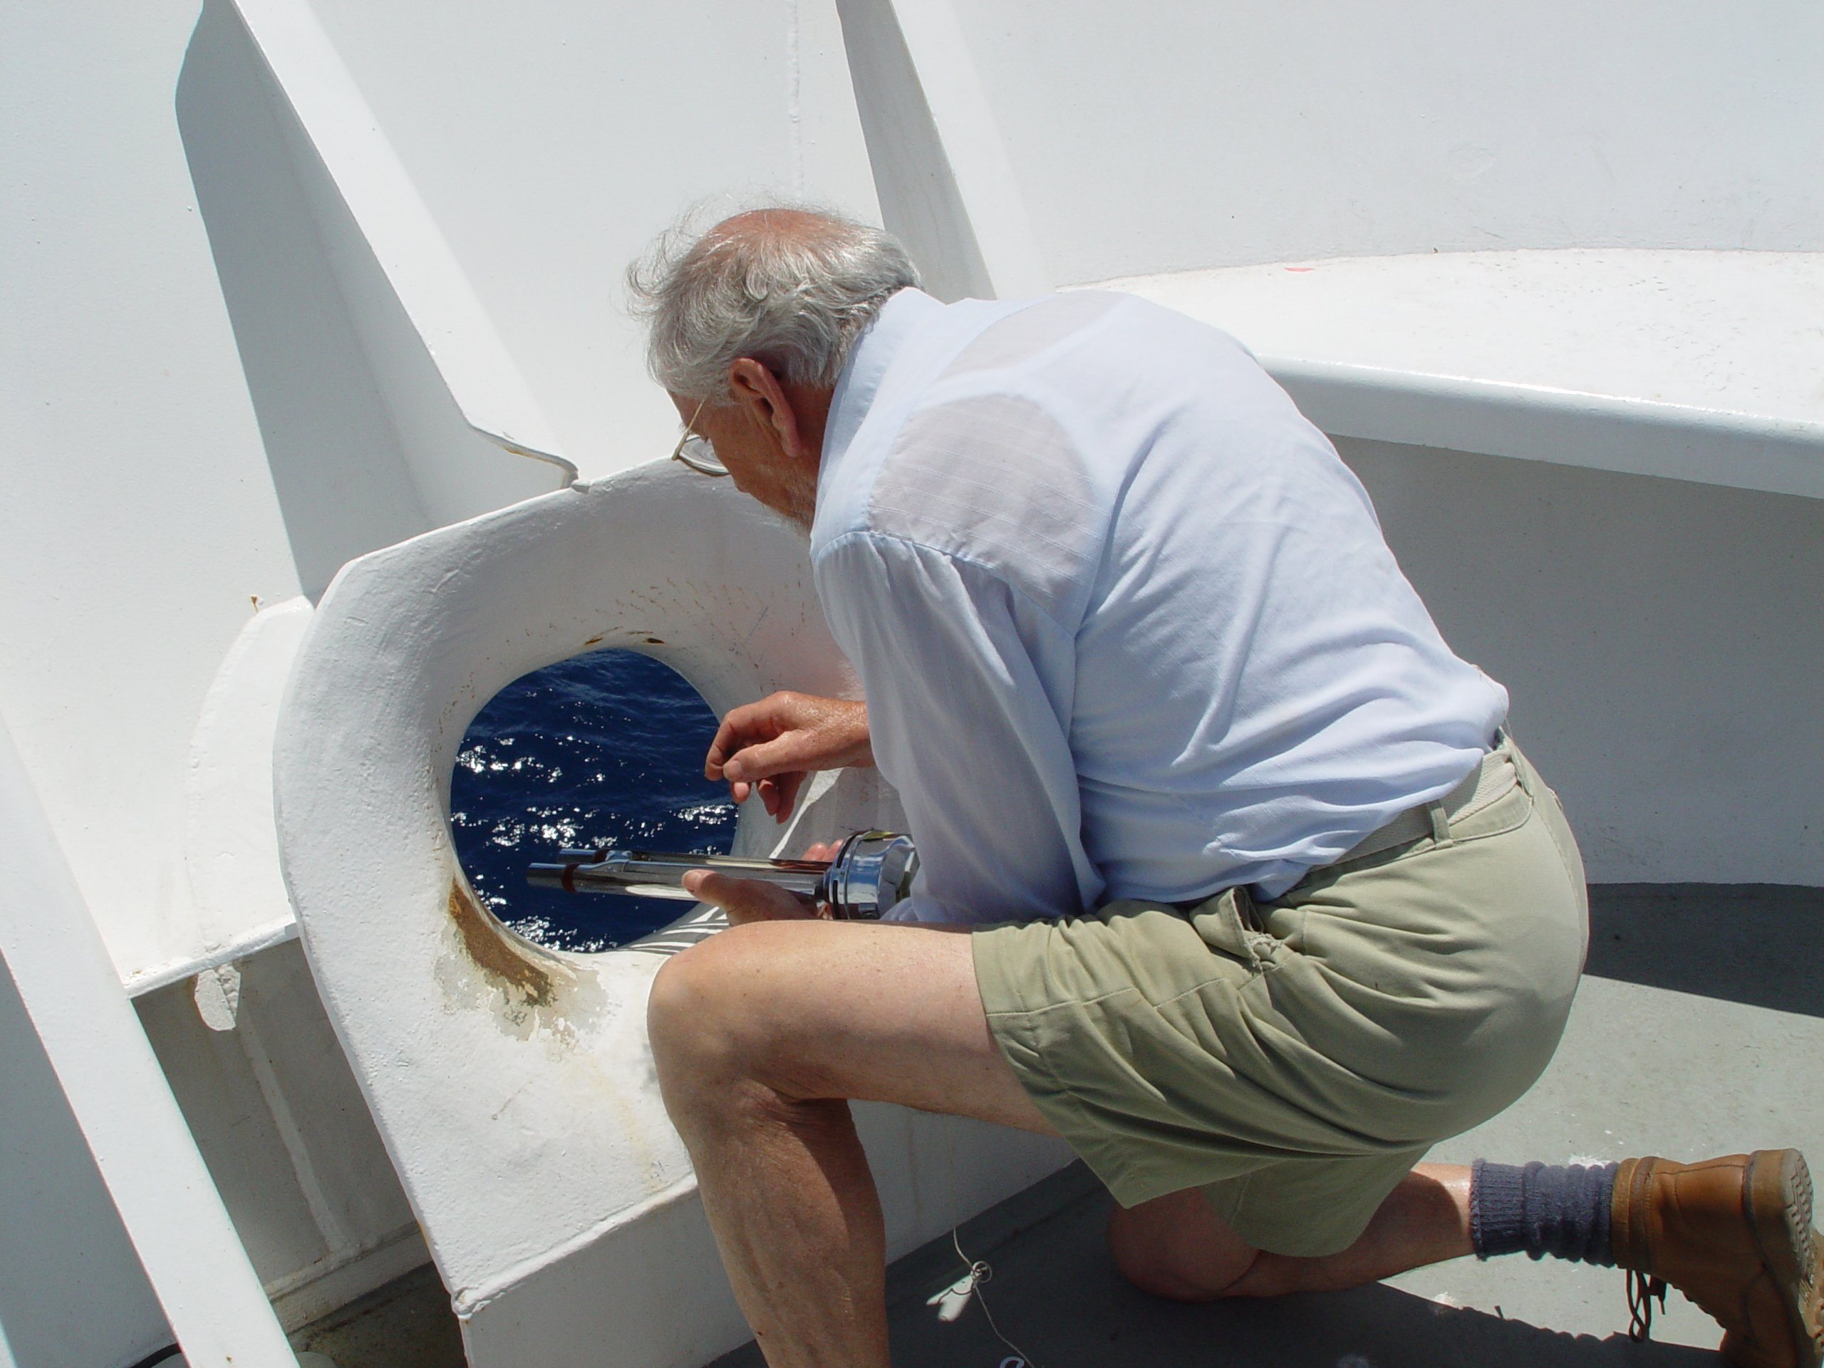

**Fig. 5.1.** Measuring wet- and dry-bulb temperatures with an Assman ventilated psychrometer. The use of the forward chock as a sampling location ensures good exposure and some shielding from the sun.

### Sea temperature

The traditional measurement is of the “bucket” temperature. The nature and probable accuracy of this method is referred to in section 3.6 of Bradley and Fairall (2006). A bucket measurement may be impossible from very large vessels, but most research ships possess such an insulated bucket. The bucket size is important: too small, and the water sample will change temperature before it can be read; too large and the bucket will be heavy and awkward to handle. The technique is to throw the bucket forward and out from the ship and bring it in when it is even with the observer. Several casts are needed to ensure that the temperature of the bucket is close to the water temperature. Obviously, the temperature should be read as soon as possible after bringing the bucket on board, but timing is not so critical because sea temperature does not fluctuate as rapidly as air temperature.

### Wind speed

The traditional estimate of wind speed at sea is by observation of its effect on sea state. Unlike cup and acoustic anemometers, the Beaufort scale (see Table E1 in Bradley and Fairall 2006) does not break, fuse, or rust and it is independent of ship speed and heading. In recent years the various sea state descriptions have been refined by comparison with careful instrumental wind measurements. As noted in Lessons 2, 3, and 4, there are several potential sources of error in the true wind measurement from instruments measuring wind and ship speed, the calculation from relative wind, and flow distortion. It is almost impossible to estimate the true wind by “feel,” so the Beaufort scale enables the observer to judge, within a couple of ms-1, whether the logged wind speed is within reasonable limits. A modern Beaufort scale, with photos of sea state for each level in the scale, can be found at <http://en.wikipedia.org/wiki/Beaufort_scale>.

### Downwelling radiation

Except under special conditions, short-term variability in solar and IR radiative fluxes, especially because of cloudiness, makes these signals the most difficult to check with spot observations. There are various parameterizations for radiative fluxes, based on surface air temperature and humidity combined with visual observations of cloud fraction, but these are too uncertain to be of use in this context. However, reliable models of these fluxes for a cloud-free sky may be used to check the radiation observations for this particular condition. The IR flux may be written, where *T*a is the air temperature (Kelvin) and εe0 an effective emissivity for clear skies for which Brunt (1932) proposed a 2-parameter form . From a database of several cruises, Hare et al. (2005) determined *A* and *B* as linear functions of latitude *φ*, such that

.

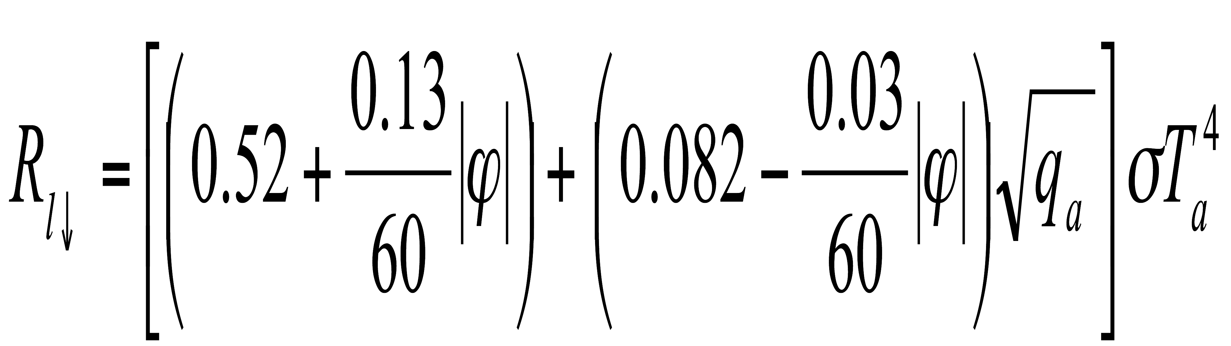

The pyrgeometer output, being a combination of three temperature signals, is vulnerable to stray thermal contamination, but this equation can provide an estimate to within ±10 Wm-2.

Clear-sky parameterizations for solar flux are also available, but they require atmospheric profiles of certain constituents and involve strong dependencies on location and season, making them too complex for checking the pyranometer. However, knowing that the solar flux falls identically to zero at night (a standard pyranometer will normally read a few Wm-2 negative at night) and has a maximum clear-sky value around 1100 Wm-2 in the tropics enables the observer to identify unreasonable values in most situations.

## 5.4. Documentation

Careful documentation of the sensor installation, calibration practices, and known data faults is an essential task of the person responsible for maintaining a shipboard meteorological system. These metadata are crucial to the future application of the observations. The importance of documenting the calibration and deployment history of each instrument cannot be emphasized too strongly. In the chaos that sometimes accompanies replacement of a faulty sensor, it is easy to postpone and eventually forget to describe the circumstances that required a sensor swap. This can subsequently lead to puzzling features in the data time series that can never be resolved with certainty. Similarly, less than optimal location of the sensor is sometimes unavoidable. If the sensor location is carefully documented (ideally supported by digital photographs), seemingly anomalous data from that sensor can often be explained, and in some cases, corrected. Equally, data from a sensor known to be very badly exposed for a given relative wind direction can be flagged as erroneous without removing the original observed values. The following list includes information that should be recorded (with date and time) prior to and during each cruise (and if possible transcribed into an electronic document).

### The basics

* Time convention (preferably GMT [UTC])
* Recorded units of observations (preferably SI)
* Ship name
* Data sampling rates
* Averaging or calculation methods (e.g., true wind vs. ocean-relative winds)

### Sensor calibration and history for each instrument

* Make/Manufacturer
* Model
* Serial number
* The date and source of each calibration (indicates stability of sensor)
* Dates of sensor deployment (and recovery)
* Incidents during deployment period (maintenance, repairs, mishaps--e.g., swamped by wave over bow)

### Instrument location

* Description and location of main support (e.g., foremast, forward rail above wheelhouse)
* Position w.r.t. main support (e.g., 1.2 m to port or stbd., 0.8 m forward)
* Position w.r.t. ship’s centerline (e.g., 2.5 m to port or stbd)
* Distance from bow
* Height above the water, and/or height above some ship reference (e.g., 15.3 m above foredeck)
* Height above the deck immediately below the sensor
* Any significant object that may affect the exposure of the instrument (e.g., Inmarsat dome on rail 2 m to port; after installation large instrument box mounted 1 m forward)

Note: The positions listed here are an example of how to define the location of a sensor on a vessel. The important message is that the location of each instrument should be referenced to a known and documented vessel coordinate system. For more information see: <http://www.rvdata.us/operators/coordsys>.

When combined with digital photography (see below), the information outlined above represents the descriptive metadata that are most commonly required to conduct data quality control or to apply the data to a scientific problem.

### Digital photography

Close-up photographs of an instrument can sometimes be helpful in detecting instrument faults (e.g., damaged cables), but photos are most useful when taken at a distance sufficient to show the sensor’s environment and possible obstacles to airflow around the sensor, and in the case of radiation sensors, objects or installations likely to cast a shadow. If possible, after installation, photographs should be taken from the wharf to capture overall vessel structure in relationship to the main meteorological instrument masts. A photo collage is also an excellent way to convey sensor locations in a single graphic (e.g., Fig. 5.2)

If written documentation were lost or mislaid, having the plans of the ship (e.g., Fig. 5.3) and photographs (e.g., Fig. 5.2) would enable estimation of the heights of the instruments and their relative positions. Digital schematics of the vessel (top and side views) showing instrument locations are also very helpful to the data user. Digital photographs of the installations and schematics enable a data analyst to assess the overall quality of the ensuing measurements and provide valuable information on the likely cause of any suspect data.

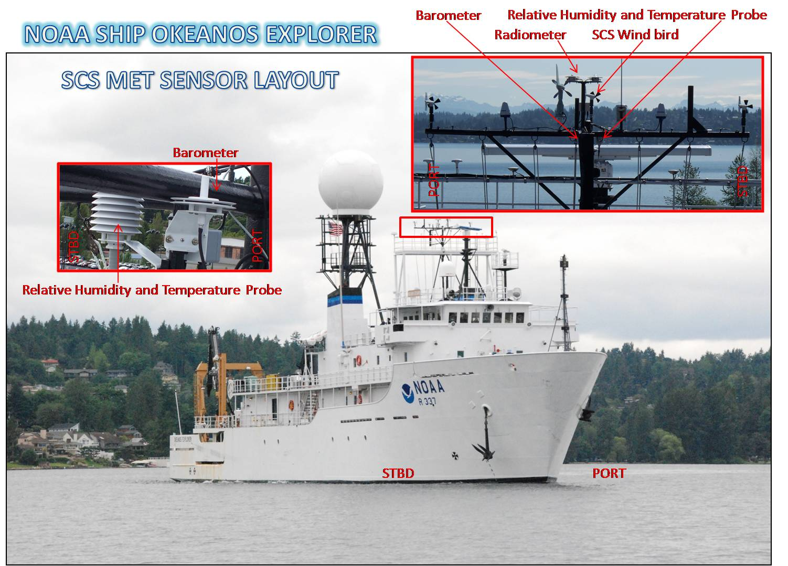

**Fig. 5.2.** A photo collage for the NOAA RV *Okeanos Explorer*. Note the insets labeling the individual sensors and showing their relationship to the vessel and instrument masts.

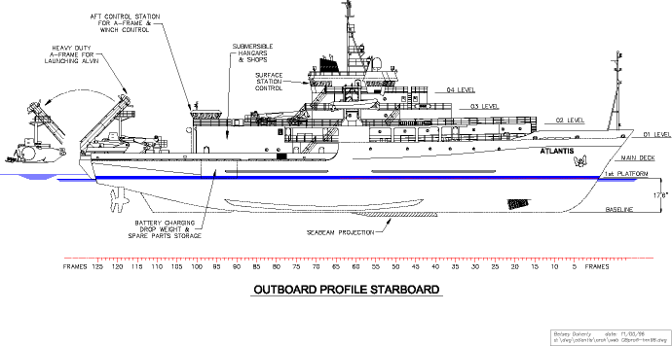**Fig. 5.3.** Side view vessel diagram for the RV *Atlantis.*

## 5.5. Data quality control

Research vessel technicians rarely perform quality control of automated marine meteorological and oceanographic data. Most quality control is completed either by users of the data or by dedicated data centers (e.g., the SAMOS data center at the Florida State University, <http://samos.coaps.fsu.edu>). Quality control typically consists of automated and manual inspection of the data time series. Automated checks include the following:

* Verifying temporal sequence
* Ensuring values are in a plausible range
* Comparing values to a known marine climatology
* Verifying physical relationships (e.g., Dew point temperature not greater than air temperature)
* Ensuring ship position is over water and distance between sequential locations is plausible (track checking)
* Validating true wind (and other) calculated values

Manual inspection of the data is often required to identify situations in which the instrument is affected by ship heating, airflow distortion, or shadowing. Manual inspection often identifies incorrect data units or calibration values assigned in the data documentation that do not match the actual observation values. The availability of vessel schematics and digital imagery is critical for performing these manual inspections.

There are many benefits to daily shoreside monitoring of the underway meteorological and oceanographic data. Foremost is timesaving for the shipboard technician. When the vessel data are transmitted to a shoreside data center, the center can perform routine quality control and submit feedback to the technician at sea when faults occur. This not only allows the technician more time to serve the needs of other shipboard operations but also provides the opportunity for the technician to promptly correct any data fault noted by the shoreside data center. Shoreside data centers also routinely track the vessel and instrument metadata, distribute the observations to secondary data users, and ensure the observations reach national and international marine archive centers.

## 5.6. Summary

Many data centers acquire the meteorological data collected automatically by a research vessel’s computer logging system and subsequently distribute the data to scientists engaged in research that is not part of the science mission of the cruise on which the data were collected. Examples of users include climate and ocean modelers, marine data product developers, and developers and operators of satellite and other remote sensing platforms. The role of the shipboard operator is to maintain the quality of the data by monitoring the performance of the sensors and by making sure that all details (e.g., time of radiometer dome cleaning, existence of a faulty instrument) are noted and disseminated in an electronic log. Quality assurance starts with the marine technician.

# References

Bradley, F. and C. Fairall, 2006: *A Guide to Making Climate Quality Meteorological and Flux Measurements at Sea*. NOAA Technical Memorandum OAR PSD-311, NOAA/ESRL/PSD, Boulder, CO, 108 pp.

Hasse, L., M. Grossklaus, K. Uhlg, and P. Timm, 1998: A ship rain gage for use in high winds. *J. Atmos. Oceanic. Tech.*, **15**, 380-386.

Smith, S.R, M.A. Bourassa, and R.J. Sharpe, 1999: Establishing more truth in true winds.  *J. Atmos. Oceanic Tech.*, **16**, 939-952.

WCRP, 1985: Scientific Plan for the Tropical Ocean and Global Atmosphere Programme. WCRP Publications Series, No. 3, WMO Tech. Doc. 64, Geneva, 146 pp.